Priory Sailing Club
Safeguarding Adults Policy and Guidelines

Policy Statement
Priory Sailing Club is committed to safeguarding adults taking part in its activities from physical, sexual, psychological, financial or discriminatory abuse or neglect. We recognise that everyone, irrespective of age, disability, gender reassignment, race, religion or belief, sex, sexual orientation, pregnancy and maternity, marriage or civil partnership or social status, has a right to protection from discrimination and abuse.
Priory Sailing Club takes all reasonable steps to ensure that, through safe recruitment, appropriate operating procedures and training, it offers a safe environment to adults at risk participating in its activities. All participants will be treated with dignity and respect. All members and volunteers should be aware of the policy.

Club Welfare Officer
The Club Welfare Officer is: Jeanette Pocock, Phone 01234 358811, 07786 154236, email jlile@hotmail.co.uk.
Staff and Volunteers
All who carry out coaching or instructing activities at Priory Sailing Club are subject to an appropriate level of scrutiny. The level of checking is proportionate to the role, the level of risk involved and is in line with relevant statutory requirements. All Club instructors will be asked to complete a self declaration form. The Club Welfare Officer will also be asked to apply for an Enhanced Criminal Records Disclosure, with Barred List check if appropriate.
All PSC Instructors undertake safeguarding training appropriate to their role. This will be through formal training which may include an online course, induction and mentoring and will include continuing professional development.
Everyone should be familiar with Safeguarding Appendix L, What is Abuse (Adults at Risk).
Good Practice
All members of the Club should follow the Priory Sailing Club Good Practice Guidelines for working with Adults at Risk (Safeguarding Appendix K) and agree to abide by the Priory Sailing Club Code of Conduct (Safeguarding Appendix B) and the RYA Racing Charter contained in the Racing Rules of Sailing. Those working or volunteering with Adults at risk should be aware of the guidance on recognising abuse.

Changing Facilities
Priory Sailing Club has separate male and female changing rooms and a unisex accessible toilet / changing room which caters for a disabled male with a female carer and vice versa. If it is essential, in an emergency situation, for a male to enter a female changing area or vice versa, it is advised that they are accompanied by another adult of the opposite sex.
First aid and medical treatment
First aid provided by an appropriately trained and qualified person, is part of an organisation’s normal duty of care. If the individual lacks the capacity to give consent, and medication or medical treatment may be required in the absence of their carer, prior consent from the carer will be obtained.
Mental Capacity and Consent
In the case of an adult, our starting assumption must always be that they have the capacity to make a decision and have the right to do so. If there is an allegation or concern about an adult who has capacity, their consent must be obtained before any referral is made, unless others are at risk of harm. No information should be given to the adult’s family or carers without their consent. If the adult does not have capacity and is unable to give consent, a referral may be made and their family or carers informed, provided that they are involved in the individual’s life and are not implicated in the allegation.
Communication and Images
The Club may arrange for photographs or videos to be taken of Club activities and published on our website or social media channels to promote the Club. Care will be taken not to identify anyone by name unless permission is given. Where photographs of young people under the age of 18 are shown either in the club house, web site or social media then sensible child protection guidelines will be used. If photographs are going to be used in press releases then parental permission will be sought first. Please note that the lake is in a public park and we have no jurisdiction about people photographing from outside of our grounds. All images are stored in line with Priory Sailing Club’s Data Privacy Policy.
The recording of images or video or use of any type of photographic equipment is not permitted in changing areas in any circumstances.
Parents and spectators should be prepared to identify themselves if requested and state their purpose for photography/filming.
Any concerns about inappropriate or intrusive photography, or about the inappropriate use of images should be reported to the Club Welfare Officer.
Responsibilities of volunteers, coaches and instructors
Priory Sailing Club members are made aware of and expected to comply with the following Priory Sailing Club Policies, Procedures and documents:
PSC Safeguarding Adults Policy and Guidelines
PSC Anti-Bullying Policy (Safeguarding Appendix C)
PSC Code of Conduct (Safeguarding Appendix B)
In addition to this, volunteers and Instructors are also made aware of and expected to comply with the following:
Priory Sailing Club Good Practice Guidelines for working with Adults at Risk (Safeguarding Appendix K)
RYA Coaches and Instructors are expected to comply with the RYA Codes and Conduct (Safeguarding Appendices D & E)
Responsibilities of Carers
Priory Sailing Club has a duty of care to our members, and particularly to adults who cannot take full responsibility for their own safety. Carers are expected to be responsible for the welfare of the adult in their care or designate another adult to take that responsibility, outside formal club-organised activities.
Concerns
Anyone who is concerned about a member’s or participant’s welfare, either outside the sport or within the Club, should follow the procedures outlined in the Safeguarding Appendix M What to do if you are concerned about an adult at risk. The Club Welfare Officer will follow the procedures outlined in this document. Historical allegations will follow the same procedure as for a new concern.
Any member of the Club failing to comply with the Safeguarding Adults policy and any relevant Codes of Conduct may be subject to disciplinary action under 3.9 of the Club’s Constitution.

Priory Sailing Club - PSC Safeguarding Appendix B
Code of Conduct for Junior Members, Adult Members, Parents,
Coaches, Instructors and Volunteers

It is the policy of Priory Sailing Club that all participants, coaches, instructors, officials, parents and volunteers show respect and understanding for each other, treat everyone equally within the context of the sport and conduct themselves in a way that reflects the principles of the club. The aim is for all participants to enjoy their sport and to improve performance.

Abusive language, swearing, intimidation, aggressive behaviour or lack of respect for others and their property will not be tolerated and may lead to disciplinary action.

Participants - young sailors, windsurfers and Junior members
• Listen to and accept what you are asked to do to improve your performance and keep you safe
• Respect other participants, coaches, instructors, officials and volunteers
• Abide by the rules and play fairly
• Do your best at all times
• Never bully others either in person, by phone, by text or online
• Take care of all property belonging to other participants, the club and its members

Parents
• Support your child’s involvement and help them enjoy their sport
• Help your child to recognise good performance, not just results
• Never force your child to take part in sport
• Never punish or belittle a child for losing or making mistakes
• Encourage and guide your child to accept responsibility for their own conduct and performance
• Respect and support the coach
• Accept officials’ judgements and recognise good performance by all participants
• Use established procedures where there is a genuine concern or dispute
• Inform the club or event organisers of relevant medical information
• Ensure that your child wears suitable clothing and has appropriate food and drink
• Provide contact details and be available when required
• Take responsibility for your child’s safety and conduct in and around the clubhouse

Carers
• Accept that adult participants have a right to take risks and to take decisions about their welfare, unless they lack the capacity to do so as defined by the Mental Health Act 2005
• Support the participant’s involvement and help them enjoy their sport
• Help the participant to recognise good performance, not just results
• Never force the participant to take part in sport
• Never punish or belittle the participant for losing or making mistakes
• Encourage and guide the participant to accept responsibility for their own conduct and performance
• Respect and support the instructor/coach
• Accept officials’ judgements and recognise good performance by all participants
• Use established procedures where there is a genuine concern or dispute
• Inform the club or event organisers of relevant medical information
• Ensure that the participant wears suitable clothing and has appropriate food and drink
• Provide contact details and be available when required
• Take responsibility for the participant’s safety and conduct in and around the clubhouse/event venue

Coaches, Instructors, and Volunteers
• Consider the welfare and safety of participants before the development of performance
• Encourage participants to value their performance and not just results
• Promote fair play and never condone cheating
• Ensure that all activities are appropriate to the age, ability and experience of those taking part
• Build relationships based on mutual trust and respect
• Work in an open environment
• Avoid unnecessary physical contact with young people
• Be an excellent role model and display consistently high standards of behaviour and appearance
• Do not drink alcohol or smoke when working directly with young people
• Communicate clearly with parents and participants
• Be aware of any relevant medical information
• Follow RYA and Priory Sailing Club guidelines and policies
• Holders of RYA Instructor and Coach qualifications must also comply with the RYA Code of Conduct
• Holders of RYA Race Official appointments must also comply with the RYA Race Officials Code of Conduct.

If you are concerned that someone is not following the Code of Conduct, you should inform your Club Welfare Officer , Jeanette Pocock or the person in charge of the activity.
Priory Sailing Club - PSC Safeguarding Appendix C
Anti-Bullying Policy
Policy Statement
This anti-bullying policy sets out how we feel about bullying as a club or organisation, what we’ll do to tackle it and how we’ll support children and young people who experience or display bullying behaviour.

Bullying
• all forms of bullying will be acted upon
• everybody in the club or organisation has a responsibility to work together to stop bullying
• bullying can include online as well as offline behaviour
• bullying behaviour can include:
- physically pushing, kicking, hitting, pinching etc.
- name calling, spreading rumours, persistent teasing and humiliation or the continual ignoring of others
- posting of derogatory or abusive comments, videos or images on social media
- racial, homophobic, transphobic or sexist comments, taunts or gestures
- sexual comments, suggestions or behaviour
- unwanted physical contact

Our club or organisation will:
• recognise its duty of care and responsibility to safeguard all children and young people from harm
• promote and implement this anti-bullying policy in addition to our safeguarding policy and procedures
• ensure that bullying behaviour is not tolerated or condoned
• require all members of Priory Sailing Club to adhere to this policy
• take action to investigate and respond to any reports of bullying from children and young people
• encourage and facilitate children and young people to play an active part in developing and adopting a code of conduct for behaviour
• ensure that Instructors and Volunteers are given access to information, guidance and training on bullying

Each participant, instructor or volunteer will:
• encourage individuals to speak out about bullying behaviour
• respect every child’s need for, and right to, a play environment where safety, security, praise, recognition and opportunity for taking responsibility are available
• respect the feelings and views of others
• recognise that everyone is important and equal, and that our differences make each of us special and worthy of being valued
• show appreciation of others by acknowledging individual qualities, contributions and progress
• ensure safety by having rules and practices carefully explained and displayed for all to see
• report incidents of bullying behaviour they see to Priory Sailing Club’s Welfare Officer (see below)

Supporting children
• we’ll let children know who will listen to and support them
• we’ll create an “open door” ethos where children feel confident to talk to an adult about bullying behaviour or any other issue that affects them
• potential barriers to talking (including those associated with a child’s disability or impairment) will be acknowledged and addressed at the outset to enable children to speak out
• we’ll make sure children are aware of helpline numbers
• anyone who reports an incident of bullying will be listened to carefully and reports will be taken seriously
• any reported experience of bullying behavior will be investigated and will involve listening carefully to all those involved
• children experiencing bullying behavior will be supported and helped to uphold their right to play and live in a safe environment
• those who display bullying behaviour will be supported and encouraged to develop better relationships
• we’ll make sure that sanctions are proportionate and fair

Support to the parents/guardians
• parents or guardians will be advised on this anti-bullying policy and practice
• any experience of bullying behaviour will be discussed with the child’s parents or guardians
• parents will be consulted on action to be taken (for both victim and bully) and we’ll agree on these actions together
• information and advice on coping with bullying will be made available
• support will be offered to parents, including information from other agencies or support lines

Club Welfare Officer
The Club Welfare Officer is: Jeanette Pocock, Phone 01234 358811, 07786 154236, email jlile@hotmail.co.uk.

Useful contacts
NSPCC Helpline 0808 800 5000
Childline 0800 1111 www.childline.org.uk
Kidscape www.kidscape.org.uk
Anti-Bullying Alliance www.antibullyingalliance.org

This Policy is adapted from Child Protection in Sport Sample Unit Anti-Bullying Policy

Priory Sailing Club - PSC Safeguarding Appendix D
RYA Coach Code of Ethics and Conduct (Revised 2018)
(Taken from RYA Safeguarding and Child Protection Guidelines Jan 2020 )

Sports Coaching helps the development of individuals through improving their performance.
This is achieved by:
1. Identifying and meeting the needs of individuals.
2. Improving performance through a progressive programme of safe, guided practice, measured performance and/or competition.
3. Creating an environment in which individuals are motivated to maintain participation and improve performance.

Coaches should comply with the principles of good ethical practice listed below.
- All RYA Coaches working with young people under the age of 18 must have read and understood the RYA Child Protection Policy as detailed on the RYA website at www.rya.org.uk/go/safeguarding . If you are unable to access the website please contact coachingdevelopment@rya.org.uk
- Coaches must respect the rights, dignity and worth of every person and treat everyone equally within the context of their sport.
- Coaches must place the well-being and safety of the sailor above the development of performance. They should follow all guidelines laid down by the RYA, follow Operating Procedures and hold appropriate insurance cover.
- Coaches must develop an appropriate working relationship with sailors based on mutual trust and respect. Coaches must not exert undue influence to obtain personal benefit or reward. In particular they must not abuse their position of trust to establish or pursue a sexual relationship with a young person aged under 18, or an inappropriate relationship with any young person.
- Coaches must encourage and guide young people to accept responsibility for their own behaviour and performance.
- Coaches must hold up to date and nationally recognised governing body coaching qualifications.
- Coaches must ensure that the activities they direct or advocate are appropriate for the age, maturity, experience and ability of the individual.
- Coaches must, at the outset, clarify with young people (and where appropriate their parents) exactly what is expected of them and what participants are entitled to expect from their coach. A contract may sometimes be appropriate.
- Coaches must co-operate fully with other specialists (eg. other coaches, officials, sports scientists, doctors, physiotherapists) in the best interests of the young person.
- Coaches must always promote the positive aspects of their sport (eg. fair play) and never condone rule violations or the use of prohibited substances.
- Coaches must consistently display high standards of behaviour and appearance.
- Coaches must notify the RYA immediately of any court imposed sanction that precludes the coach from contact with a specific user group (eg. children and vulnerable adults).
- Coaches must not carry out coaching activities whilst under the influence of alcohol or drugs, or when they have received medical advice not to continue activities that are connected with their coaching (eg. driving).
- Coaches must not behave in a way which brings the sport into disrepute.

Failure to adhere to the RYA Coach Code of Conduct may result in the suspension or withdrawal of RYA qualifications or appointments and will be dealt with in line with the RYA Coaches’ Performance Guidelines.
To access these Guidelines please contact coachingdevelopment@rya.org.uk

Priory Sailing Club - PSC Safeguarding Appendix E
RYA Instructor Code of Conduct for RYA Instructors, Coach Assessors, Trainers and Examiners (Revised 2014)
(Taken from RYA Safeguarding and Child Protection Guidelines Jan 2020 )

This document outlines the code of conduct under which all holders of RYA instructor qualifications and RYA training appointments (hereafter referred to as instructors) are required to comply.

The code of conduct is intended to make clear to all participants, instructors and RYA appointment holders the high standards to which all are expected to conform.

Instructors must:
• If working with people under the age of 18, read and understand the Child Protection Policy as detailed on the RYA website at www.rya.org.uk
• Respect the rights, dignity and worth of every person and treat everyone equally within the context of their sport.
• Place the wellbeing and safety of the student above the development of performance or delivery of training.
•Follow all guidelines laid down by the RYA with regards specific training or coaching programmes.
• Hold appropriate insurance cover either individually or through the training centre in which they are working.
• Not develop inappropriate working relationships with students (especially children). Relationships must be based on mutual trust and respect and not exert undue influence to obtain personal benefit or reward.
• Encourage and guide students to accept responsibility for their own behaviour and performance.
• Hold relevant up to date governing body qualifications as approved by the RYA.
• Ensure that the activities they direct or advocate are appropriate for the age, maturity, experience and ability of the individual.
• At the outset, clarify with students (and where appropriate their parents) exactly what is expected of them and what they are entitled to expect.
• Always promote the positive aspects of the sport (eg courtesy to other water users).
• Consistently display high standards of behaviour and appearance.
• Not do or neglect to do anything which may bring the RYA into disrepute.
• Act with integrity in all customer and business to business dealings pertaining to RYA training.
• Not teach or purport to provide RYA courses or RYA certification outside of the framework of an RYA recognised training centre
• Notify the RYA immediately of any court imposed sanction that precludes the instructor from contact with specific user groups (for example children and vulnerable adults).
• Not carry out RYA training, examining or coaching activities whilst under the influence of alcohol or drugs.

Failure to adhere to the RYA Instructor Code of Conduct may result in the suspension or withdrawal of RYA qualifications or appointments.

Priory Sailing Club - PSC Safeguarding Appendix K
Good Practice Guide for Instructors, Coaches and Volunteers working with
Adults at Risk
This guide only covers the essential points of good practice when working with adults at risk.
You should also read Priory Sailing Club Safeguarding Adults Policy and Guidelines which are available for reference at all times.

• Always communicate clearly, in whatever way best suits the individual, and check their understanding and expectations
• Always try to work in an open environment in view of others
• Avoid spending any significant time working with adults at risk in isolation
• Do not take an adult at risk alone in a car, however short the journey, unless you are certain that the individual has the capacity to decide to accept a lift
• Do not take an adult at risk to your home as part of your organisation’s activity
• Where any of these is unavoidable, ensure that it only occurs with the full knowledge and consent of someone in charge of the organisation or the person’s carers
• Design training programmes that are within the ability of the individual
• If you need to help someone with a wetsuit or buoyancy aid or provide physical assistance or support, make sure you are in full view of others
• Take great care with communications via mobile phone, e-mail or social media that might be misunderstood or shared inappropriately. In general, only send group communications about organisational matters using these methods. If it’s essential to send an individual message to a person who has a learning disability or other impairment that might affect their understanding, copy it to their carer.

You should never:
• engage in rough, physical or sexually provocative games or activities
• allow or engage in inappropriate touching of any form
• use inappropriate language • make sexually suggestive comments, even in fun
• fail to respond to an allegation made by an adult at risk; always act
• do things of a personal nature that the person can do for themselves.

It may sometimes be necessary to do things of a personal nature to help someone with a physical or learning disability. These tasks should only be carried out with the full understanding and consent of both the individual (where possible) and their carers. In an emergency situation which requires this type of help, if the individual lacks the capacity to give consent, carers should be fully informed. In such situations it is important to ensure that anyone present is sensitive to the individual and undertakes personal care tasks with the utmost discretion.
Priory Sailing Club - PSC Safeguarding Appendix L
What is Abuse? (Adults at Risk)
(Based on the statutory guidance supporting the implementation of the Care Act 2014)

Abuse is a violation of an individual’s human and civil rights by another person or persons. Adults at risk may be abused by a wide range of people including family members, professional staff, care workers, volunteers, other service users, neighbours, friends, and individuals who deliberately exploit vulnerable people.
Abuse may occur when an adult at risk lives alone or with a relative, within nursing, residential or day care settings, hospitals and other places assumed to be safe, or in public places.
The following is not intended to be an exhaustive list of types of abuse or exploitation but an illustrative guide as to the sort of behaviour which could give rise to a safeguarding concern:

Physical abuse - including assault, hitting, slapping, pushing, misuse of medication, restraint, or inappropriate physical sanctions.

Domestic violence – including psychological, physical, sexual, financial, emotional abuse; so called ‘honour’ based violence. This won’t happen at a club/centre, but there could be concerns about a participant’s home situation.

Sexual abuse - including rape, indecent exposure, sexual harassment, inappropriate looking or touching, sexual teasing or innuendo, sexual photography, subjections to pornography or witnessing sexual acts, indecent exposure and sexual assault or sexual acts to which the adult has not consented or was pressured into consenting.

Psychological abuse - including emotional abuse, threats of harm or abandonment, deprivation of contact, humiliation, blaming, controlling, intimidation, coercion, harassment, verbal abuse, isolation or unreasonable and unjustified withdrawal from services or supportive networks. In a club context this might include excluding a member from social activities.

Financial or material abuse - including theft, fraud, internet scamming, coercion in relation to an adult’s financial affairs or arrangements, including in connection with wills, property, inheritance or financial transactions, or the misuse or misappropriation of property, possessions or benefits. People with learning disabilities or dementia are particularly vulnerable to this type of abuse. An example might be encouraging someone to book and pay for training courses that are inappropriate for their level of ability, or to purchase sailing clothing or equipment they don’t need.
Discriminatory abuse - including forms of harassment, slurs or similar treatment; because of race, gender and gender identity, age, disability, sexual orientation or religion.

Neglect and acts of omission - including ignoring medical, emotional or physical care needs, failure to provide access to appropriate health, care and support or educational services, the withholding of the necessities of life, such as medication, adequate nutrition and heating; or in a watersports context, failing to ensure that the person is adequately protected from the cold or sun or properly hydrated while on the water.

Self-neglect – this covers a wide range of behaviour neglecting to care for one’s personal hygiene, health or surroundings and includes behaviour such as hoarding. Self-neglect might indicate that the person is not receiving adequate support or care, or could be an indication of a mental health issue such as depression.

Organisational abuse – including neglect and poor care practice within an institution or specific care setting such as a hospital or care home, for example, or in relation to care provided in one’s own home. This may range from one-off incidents to on-going illtreatment. It can be through neglect or poor professional practice as a result of the structure, policies, processes and practices within an organisation.

Modern slavery – encompasses slavery, human trafficking, forced labour and domestic servitude. Traffickers and slave masters use whatever means they have at their disposal to coerce, deceive and force individuals into a life of abuse, servitude and inhumane treatment.

Not included in the Care Act 2014 but also relevant:
Bullying (including ‘cyber bullying’ by text, e-mail, social media etc) - may be seen as deliberately hurtful behaviour, usually repeated or sustained over a period of time, where it is difficult for those being bullied to defend themselves. The bully may be another vulnerable person. Although anyone can be the target of bullying, victims are typically shy, sensitive and perhaps anxious or insecure. Sometimes they are singled out for physical reasons – being overweight, physically small, having a disability - or for belonging to a different race, faith or culture.

Mate Crime – a ‘mate crime’ as defined by the Safety Net Project is ‘when vulnerable people are befriended by members of the community who go on to exploit and take advantage of them. It may not be an illegal act but still has a negative effect on the individual’. Mate Crime is carried out by someone the adult knows.

Radicalisation - the aim of radicalisation is to inspire new recruits, embed extreme views and persuade vulnerable individuals to the legitimacy of a cause. This may be direct through a relationship, or through social media.

Recognising abuse
Patterns of abuse vary and include:
• Serial abusing in which the perpetrator seeks out and ‘grooms’ individuals. Sexual abuse sometimes falls into this pattern as do some forms of financial abuse
• Long-term abuse in the context of an ongoing family relationship such as domestic violence between spouses or generations or persistent psychological abuse; or
• Opportunistic abuse such as theft occurring because money or valuable items have been left lying around.

Signs and indicators that may suggest someone is being abused or neglected include:
• Unexplained bruises or injuries – or lack of medical attention when an injury has occurred
• Someone losing or gaining weight, or an unkempt appearance
• A change in behaviour or confidence
• Self-harming
• A person’s belongings or money go missing
• The person is not attending, or no longer enjoying, their sessions
• A person has a fear of a particular group or individual
• A disclosure – someone tells you or another person that they are being abused.

If you are concerned
If there are concerns about abuse taking place in the person’s home, talking to their carers might put them at greater risk. Please refer to ‘Priory Sailing Club’s document ‘What to do if you are concerned about an adult at risk’.
Our designated Welfare Officer is Jeanette Pocock and it is this person’s responsibility to make the decision to contact Adult Social Care Services. It is NOT their responsibility to decide if abuse is taking place, BUT it is their responsibility to act on your concerns.

Priory Sailing Club - PSC Safeguarding Appendix M
What to do if you are concerned about an adult at risk
(Adapted from RYA Safeguarding and Child Protection Guidelines Jan 2020 )

Anyone who is concerned about an adult’s welfare, either outside the sport or within the Club, should follow the flowcharts below. Historical allegations should follow the same procedure as for a new concern.

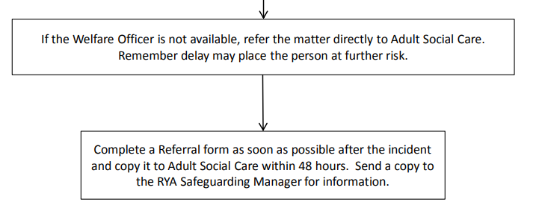
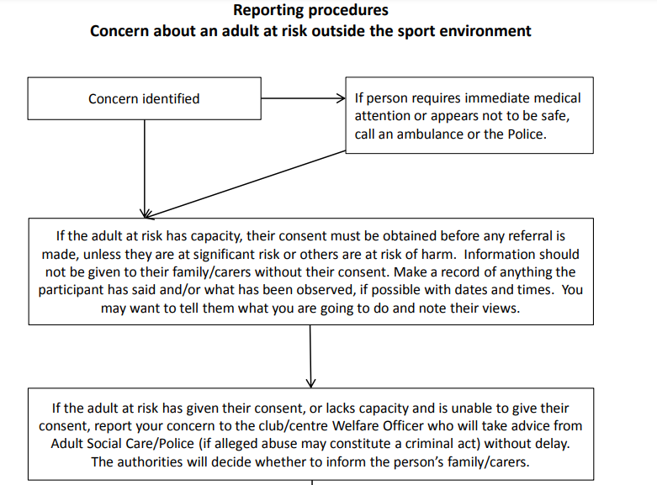
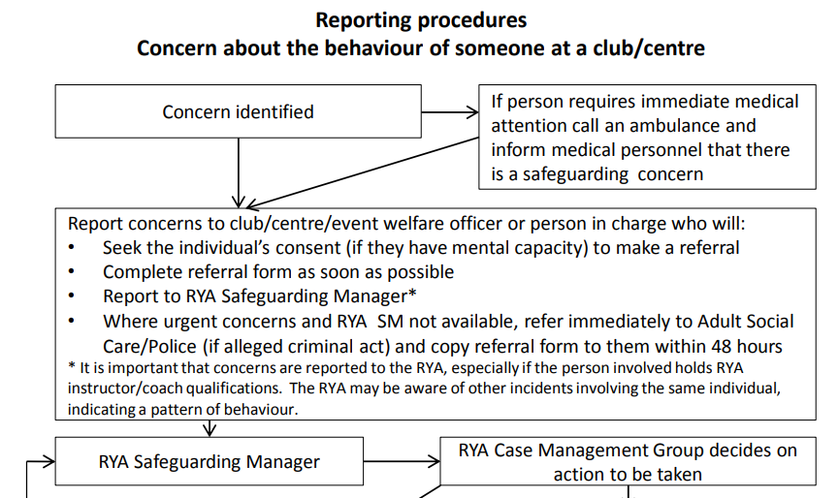
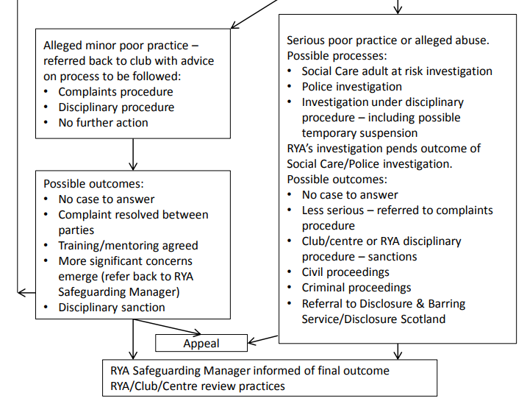
If the concern is about someone at the club, the following flowchart should be followed:

Useful Contacts
Details of Social Care departments and emergency duty teams are listed below. If you are unable to find the appropriate contact number, call the RYA’s Safeguarding and Equality Manager or, if an adult is at immediate risk, ring the Police on 999

Priory Sailing Club Welfare Officer
Jeanette Pocock 01234 358811, 07786 154236 jlile@hotmail.co.uk

Bedford Borough Adult Safeguarding Team
The Safeguarding Adults Team is available during Council working hours (Monday to Thursday 8:45am to 5:20pm and Friday 8:45am to 4:20pm).
Address: Borough Hall, Cauldwell Street, Bedford, MK42 9AP
Tel: 01234 276222
Outside of these times the Emergency Duty Team should be contacted on 0300 300 8123.

Royal Yachting Association Safeguarding and Equality Manager
RYA House, Ensign Way Hamble Southampton SO31 4YA
Tel: 023 8060 4104
E-mail: safeguarding@rya.org.uk
Website: www.rya.org.uk/go/safeguarding

Ann Craft Trust
The Ann Craft Trust (ACT) supports organisations in the statutory, independent and voluntary sectors across the UK to protect disabled children and adults at risk
Tel: 0115 951 5400
Website: http://www.anncrafttrust.org/safeguarding-adults-sport-activity/

Action on Elder Abuse helpline
Tel: 0808 808 8141
Website: www.elderabuse.org.uk

Dementia UK
Tel: 0800 888 6678
Website: www.dementiauk.org

Mencap
Direct Tel: 0808 808 1111
E-mail: help@mencap.org.uk
Website: www.mencap.org.uk

MIND – mental health charity
Tel: 0300 123 3393 Text: 86463
E-mail: info@mind.org.uk
Website: www.mind.org.uk

National Autistic Society
Tel: 0808 800 4104
Website: www.autism.org.uk

SCOPE – disability equality charity (England and Wales)
Tel: 0808 800 3333
E-mail: helpline@scope.org.uk
Website: www.scope.org.uk

Victim Support
Tel: 0808 168 9111
www.victimsupport.org.uk

