Priory Sailing Club
Safeguarding and Child Protection Policy and Guidelines

Policy Statement
Priory Sailing Club is committed to safeguarding children taking part in its activities from physical, sexual or emotional harm, neglect or bullying. We recognise that the safety, welfare and needs of the child are paramount and that any child, irrespective of age, disability, race, religion or belief, sex, sexual or gender identity or social status, has a right to protection from discrimination and abuse. Priory Sailing Club takes all reasonable steps to ensure that, through safe recruitment, appropriate operating procedures and training, it offers a safe and fun environment to children taking part in its events and activities. For the purposes of this policy anyone under the age of 18 should be considered as a child. All members of the Club should be aware of the policy.
Club Welfare Officer
The Club Welfare Officer is: Jeanette Pocock, Phone 01234 358811, 07786 154236, email jlile@hotmail.co.uk.
Staff and Volunteers
All who carry out coaching or instructing activities at Priory Sailing Club are subject to an appropriate level of scrutiny. The level of checking is proportionate to the role, the level of risk involved and is in line with relevant statutory requirements. All Club instructors will be asked to complete a Self Declaration Form (Safeguarding Appendix G). The Club Welfare Officer will also be asked to apply for an Enhanced Criminal Records Disclosure, with Barred List check if appropriate.
All PSC Instructors undertake safeguarding training appropriate to their role. This will be through formal training which may include an online course, induction and mentoring and will include continuing professional development.
Everyone should be familiar with Safeguarding Appendix H, What is Child Abuse.
Good Practice
All members of the Club should follow the Priory Sailing Club Good Practice Guidelines for working with Children and Young People (Safeguarding Appendix A) and agree to abide by the Priory Sailing Club Code of Conduct (Safeguarding Appendix B) and the RYA Racing Charter contained in the Racing Rules of Sailing. Those working or volunteering with young people should be aware of the guidance on recognising abuse.

Changing Facilities
Priory Sailing Club has separate male and female changing rooms and a unisex accessible toilet / changing room.
While it is preferable for adults to stay away from the changing rooms when there are children there, Priory Sailing Club recognises that this may not always be possible due to adults and juniors sailing at the same times, or the site is being used by multiple groups. Parents are made aware that adult club members and/or members of the public may be using the changing rooms at the same time as juniors and that it is their responsibility to supervise their children appropriately. If it is essential, in an emergency situation, for a male to enter a female changing area or vice versa, it is advised that they are accompanied by another adult of the opposite sex.
First aid and medical treatment
During organised Club activities, First Aid will be provided by an appropriately trained and qualified person as part of Priory Sailing Club’s normal duty of care. Priory Sailing Club will obtain consent if medication or medical treatment is required in the absence of the parent/carer.
Communication and Images
The Club may arrange for photographs or videos to be taken of Club activities and published on our website or social media channels to promote the Club. Care will be taken not to identify anyone by name unless permission is given. Where photographs of young people under the age of 18 are shown either in the club house, web site or social media then sensible child protection guidelines will be used. If photographs are going to be used in press releases then parental permission will be sought first. Please note that the lake is in a public park and we have no jurisdiction about people photographing from outside of our grounds. All images are stored in line with Priory Sailing Club’s Data Privacy Policy.
The recording of images or video or use of any type of photographic equipment is not permitted in changing areas in any circumstances.
Parents and spectators should be prepared to identify themselves if requested and state their purpose for photography/filming.
Any concerns about inappropriate or intrusive photography, or about the inappropriate use of images should be reported to the Club Welfare Officer.
Responsibilities of volunteers, coaches and instructors
Priory Sailing Club members are made aware of and expected to comply with the following Priory Sailing Club Policies, Procedures and documents:
PSC Safeguarding and Child Protection Policy and Guidelines
PSC Anti-Bullying Policy (Safeguarding Appendix C)
PSC Code of Conduct (Safeguarding Appendix B)
In addition to this, volunteers and Instructors are also made aware of and expected to comply with the following:
PSC Good Practice Guidelines for working with Children and Young People (Safeguarding Appendix A)
RYA Coaches and Instructors are expected to comply with the RYA Codes and Conduct (Safeguarding Appendices D & E)
Responsibilities of Parents / Carers
Priory Sailing Club has a duty of care to our members, and particularly to young people who cannot take full responsibility for their own safety. Parents and carers are expected to be responsible for their children’s welfare and behaviour, or designate another adult to take that responsibility, outside formal club-organised activities.
Concerns
Anyone who is concerned about a young member’s or participant’s welfare, either outside the sport or within the Club, should follow the procedures outlined in the Safeguarding Appendix F What to do if you are concerned about a child. The Club Welfare Officer will follow the procedures outlined in this document and may include the use of a Safeguarding and Child Protection Referral Form (Safeguarding Appendix J). Historical allegations will follow the same procedure as for a new concern.
Any member of the Club failing to comply with the Safeguarding Policy or any relevant Codes of Conduct may be subject to disciplinary action under 3.9 of the Club’s Constitution.

Priory Sailing Club - PSC Safeguarding Appendix A
Good Practice Guide for Instructors, Coaches and Volunteers working with Children and Young People
This guide only covers the essential points of good practice when working with children and young people. You should also read Priory Sailing Club Safeguarding and Child Protection Policy which are available for reference at all times.

• Avoid spending any significant time working with children in isolation.
• Do not take children alone in a car, however short the journey.
• Do not take children to your home as part of Priory Sailing Club activity.
• Where any of these are unavoidable, ensure that they only occur with the full knowledge and consent of someone in charge of the organisation or the child’s parents
• Training programmes will be designed to be within the ability of the individual child
• If a child is having difficulty with a wetsuit or buoyancy aid, ask them to ask a friend to help if at all possible
• If you do have to help a child, make sure you are in full view of others, preferably another adult
• Direct communications with young people via mobile phone, e-mail or social media group communications about organisational matters will be avoided if possible. If it’s essential to send an individual message, copy it to the child’s parent or carer.

You should never:
• engage in rough, physical or sexually provocative games
• allow or engage in inappropriate touching of any form
• allow children to use inappropriate language unchallenged, or use such language yourself when with children • make sexually suggestive comments to a child, even in fun
• fail to respond to an allegation made by a child; always act
• do things of a personal nature that children can do for themselves.

It may sometimes be necessary to do things of a personal nature for children, particularly if they are very young or disabled. These tasks should only be carried out with the full understanding and consent of the child (where possible) and their parents/carers. In an emergency situation which requires this type of help, parents should be fully informed. In such situations it is important to ensure that any adult present is sensitive to the child and undertakes personal care tasks with the utmost discretion
Additional guidance for instructors and coaches on handling young people who display challenging behaviour is available as a download from the RYA website www.rya.org.uk/go/safeguarding

Priory Sailing Club - PSC Safeguarding Appendix B
Code of Conduct for Junior Members, Adult Members, Parents,
Coaches, Instructors and Volunteers

It is the policy of Priory Sailing Club that all participants, coaches, instructors, officials, parents and volunteers show respect and understanding for each other, treat everyone equally within the context of the sport and conduct themselves in a way that reflects the principles of the club. The aim is for all participants to enjoy their sport and to improve performance.

Abusive language, swearing, intimidation, aggressive behaviour or lack of respect for others and their property will not be tolerated and may lead to disciplinary action.

Participants - young sailors, windsurfers and Junior members
• Listen to and accept what you are asked to do to improve your performance and keep you safe
• Respect other participants, coaches, instructors, officials and volunteers
• Abide by the rules and play fairly
• Do your best at all times
• Never bully others either in person, by phone, by text or online
• Take care of all property belonging to other participants, the club and its members

Parents
• Support your child’s involvement and help them enjoy their sport
• Help your child to recognise good performance, not just results
• Never force your child to take part in sport
• Never punish or belittle a child for losing or making mistakes
• Encourage and guide your child to accept responsibility for their own conduct and performance
• Respect and support the coach
• Accept officials’ judgements and recognise good performance by all participants
• Use established procedures where there is a genuine concern or dispute
• Inform the club or event organisers of relevant medical information
• Ensure that your child wears suitable clothing and has appropriate food and drink
• Provide contact details and be available when required
• Take responsibility for your child’s safety and conduct in and around the clubhouse

Carers

• Support the participant’s involvement and help them enjoy their sport
• Help the participant to recognise good performance, not just results
• Never force the participant to take part in sport
• Never punish or belittle the participant for losing or making mistakes
• Encourage and guide the participant to accept responsibility for their own conduct and performance
• Respect and support the instructor/coach
• Accept officials’ judgements and recognise good performance by all participants
• Use established procedures where there is a genuine concern or dispute
• Inform the club or event organisers of relevant medical information
• Ensure that the participant wears suitable clothing and has appropriate food and drink
• Provide contact details and be available when required
• Take responsibility for the participant’s safety and conduct in and around the clubhouse/event venue

Coaches, Instructors, and Volunteers
• Consider the welfare and safety of participants before the development of performance
• Encourage participants to value their performance and not just results
• Promote fair play and never condone cheating
• Ensure that all activities are appropriate to the age, ability and experience of those taking part
• Build relationships based on mutual trust and respect
• Work in an open environment
• Avoid unnecessary physical contact with young people
• Be an excellent role model and display consistently high standards of behaviour and appearance
• Do not drink alcohol or smoke when working directly with young people
• Communicate clearly with parents and participants
• Be aware of any relevant medical information
• Follow RYA and Priory Sailing Club guidelines and policies
• Holders of RYA Instructor and Coach qualifications must also comply with the RYA Code of Conduct
• Holders of RYA Race Official appointments must also comply with the RYA Race Officials Code of Conduct.

If you are concerned that someone is not following the Code of Conduct, you should inform your Club Welfare Officer , Jeanette Pocock or the person in charge of the activity.
Priory Sailing Club - PSC Safeguarding Appendix C
Anti-Bullying Policy
Policy Statement
This anti-bullying policy sets out how we feel about bullying as a club or organisation, what we’ll do to tackle it and how we’ll support children and young people who experience or display bullying behaviour.

Bullying
• all forms of bullying will be acted upon
• everybody in the club or organisation has a responsibility to work together to stop bullying
• bullying can include online as well as offline behaviour
• bullying behaviour can include:
- physically pushing, kicking, hitting, pinching etc.
- name calling, spreading rumours, persistent teasing and humiliation or the continual ignoring of others
- posting of derogatory or abusive comments, videos or images on social media
- racial, homophobic, transphobic or sexist comments, taunts or gestures
- sexual comments, suggestions or behaviour
- unwanted physical contact

Our club or organisation will:
• recognise its duty of care and responsibility to safeguard all children and young people from harm
• promote and implement this anti-bullying policy in addition to our safeguarding policy and procedures
• ensure that bullying behaviour is not tolerated or condoned
• require all members of Priory Sailing Club to adhere to this policy
• take action to investigate and respond to any reports of bullying from children and young people
• encourage and facilitate children and young people to play an active part in developing and adopting a code of conduct for behaviour
• ensure that Instructors and Volunteers are given access to information, guidance and training on bullying

Each participant, instructor or volunteer will:
• encourage individuals to speak out about bullying behaviour
• respect every child’s need for, and right to, a play environment where safety, security, praise, recognition and opportunity for taking responsibility are available
• respect the feelings and views of others
• recognise that everyone is important and equal, and that our differences make each of us special and worthy of being valued
• show appreciation of others by acknowledging individual qualities, contributions and progress
• ensure safety by having rules and practices carefully explained and displayed for all to see
• report incidents of bullying behaviour they see to Priory Sailing Club’s Welfare Officer (see below)

Supporting children
• we’ll let children know who will listen to and support them
• we’ll create an “open door” ethos where children feel confident to talk to an adult about bullying behaviour or any other issue that affects them
• potential barriers to talking (including those associated with a child’s disability or impairment) will be acknowledged and addressed at the outset to enable children to speak out
• we’ll make sure children are aware of helpline numbers
• anyone who reports an incident of bullying will be listened to carefully and reports will be taken seriously
• any reported experience of bullying behavior will be investigated and will involve listening carefully to all those involved
• children experiencing bullying behavior will be supported and helped to uphold their right to play and live in a safe environment
• those who display bullying behaviour will be supported and encouraged to develop better relationships
• we’ll make sure that sanctions are proportionate and fair

Support to the parents/guardians
• parents or guardians will be advised on this anti-bullying policy and practice
• any experience of bullying behaviour will be discussed with the child’s parents or guardians
• parents will be consulted on action to be taken (for both victim and bully) and we’ll agree on these actions together
• information and advice on coping with bullying will be made available
• support will be offered to parents, including information from other agencies or support lines

Club Welfare Officer
The Club Welfare Officer is: Jeanette Pocock, Phone 01234 358811, 07786 154236, email jlile@hotmail.co.uk.

Useful contacts
NSPCC Helpline 0808 800 5000
Childline 0800 1111 www.childline.org.uk
Kidscape www.kidscape.org.uk
Anti-Bullying Alliance www.antibullyingalliance.org

This Policy is adapted from Child Protection in Sport Sample Unit Anti-Bullying Policy

Priory Sailing Club - PSC Safeguarding Appendix D
RYA Coach Code of Ethics and Conduct (Revised 2018)
(Taken from RYA Safeguarding and Child Protection Guidelines Jan 2020 )

Sports Coaching helps the development of individuals through improving their performance.
This is achieved by:
1. Identifying and meeting the needs of individuals.
2. Improving performance through a progressive programme of safe, guided practice, measured performance and/or competition.
3. Creating an environment in which individuals are motivated to maintain participation and improve performance.

Coaches should comply with the principles of good ethical practice listed below.
- All RYA Coaches working with young people under the age of 18 must have read and understood the RYA Child Protection Policy as detailed on the RYA website at www.rya.org.uk/go/safeguarding . If you are unable to access the website please contact coachingdevelopment@rya.org.uk
- Coaches must respect the rights, dignity and worth of every person and treat everyone equally within the context of their sport.
- Coaches must place the well-being and safety of the sailor above the development of performance. They should follow all guidelines laid down by the RYA, follow Operating Procedures and hold appropriate insurance cover.
- Coaches must develop an appropriate working relationship with sailors based on mutual trust and respect. Coaches must not exert undue influence to obtain personal benefit or reward. In particular they must not abuse their position of trust to establish or pursue a sexual relationship with a young person aged under 18, or an inappropriate relationship with any young person.
- Coaches must encourage and guide young people to accept responsibility for their own behaviour and performance.
- Coaches must hold up to date and nationally recognised governing body coaching qualifications.
- Coaches must ensure that the activities they direct or advocate are appropriate for the age, maturity, experience and ability of the individual.
- Coaches must, at the outset, clarify with young people (and where appropriate their parents) exactly what is expected of them and what participants are entitled to expect from their coach. A contract may sometimes be appropriate.
- Coaches must co-operate fully with other specialists (eg. other coaches, officials, sports scientists, doctors, physiotherapists) in the best interests of the young person.
- Coaches must always promote the positive aspects of their sport (eg. fair play) and never condone rule violations or the use of prohibited substances.
- Coaches must consistently display high standards of behaviour and appearance.
- Coaches must notify the RYA immediately of any court imposed sanction that precludes the coach from contact with a specific user group (eg. children and vulnerable adults).
- Coaches must not carry out coaching activities whilst under the influence of alcohol or drugs, or when they have received medical advice not to continue activities that are connected with their coaching (eg. driving).
- Coaches must not behave in a way which brings the sport into disrepute.

Failure to adhere to the RYA Coach Code of Conduct may result in the suspension or withdrawal of RYA qualifications or appointments and will be dealt with in line with the RYA Coaches’ Performance Guidelines.
To access these Guidelines please contact coachingdevelopment@rya.org.uk

Priory Sailing Club - PSC Safeguarding Appendix E
RYA Instructor Code of Conduct for RYA Instructors, Coach Assessors, Trainers and Examiners (Revised 2014)
(Taken from RYA Safeguarding and Child Protection Guidelines Jan 2020 )

This document outlines the code of conduct under which all holders of RYA instructor qualifications and RYA training appointments (hereafter referred to as instructors) are required to comply.

The code of conduct is intended to make clear to all participants, instructors and RYA appointment holders the high standards to which all are expected to conform.

Instructors must:
• If working with people under the age of 18, read and understand the Child Protection Policy as detailed on the RYA website at www.rya.org.uk
• Respect the rights, dignity and worth of every person and treat everyone equally within the context of their sport.
• Place the wellbeing and safety of the student above the development of performance or delivery of training.
•Follow all guidelines laid down by the RYA with regards specific training or coaching programmes.
• Hold appropriate insurance cover either individually or through the training centre in which they are working.
• Not develop inappropriate working relationships with students (especially children). Relationships must be based on mutual trust and respect and not exert undue influence to obtain personal benefit or reward.
• Encourage and guide students to accept responsibility for their own behaviour and performance.
• Hold relevant up to date governing body qualifications as approved by the RYA.
• Ensure that the activities they direct or advocate are appropriate for the age, maturity, experience and ability of the individual.
• At the outset, clarify with students (and where appropriate their parents) exactly what is expected of them and what they are entitled to expect.
• Always promote the positive aspects of the sport (eg courtesy to other water users).
• Consistently display high standards of behaviour and appearance.
• Not do or neglect to do anything which may bring the RYA into disrepute.
• Act with integrity in all customer and business to business dealings pertaining to RYA training.
• Not teach or purport to provide RYA courses or RYA certification outside of the framework of an RYA recognised training centre
• Notify the RYA immediately of any court imposed sanction that precludes the instructor from contact with specific user groups (for example children and vulnerable adults).
• Not carry out RYA training, examining or coaching activities whilst under the influence of alcohol or drugs.

Failure to adhere to the RYA Instructor Code of Conduct may result in the suspension or withdrawal of RYA qualifications or appointments.

Priory Sailing Club - PSC Safeguarding Appendix F
What to do if you are concerned about a child
(Adapted from RYA Safeguarding and Child Protection Guidelines Jan 2020 )

Anyone who is concerned about a young member’s or participant’s welfare, either outside the sport or within the Club, should follow the flowcharts below. Historical allegations should follow the same procedure as for a new concern.
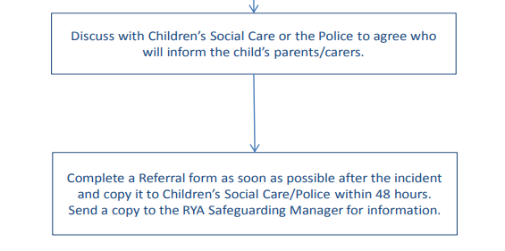
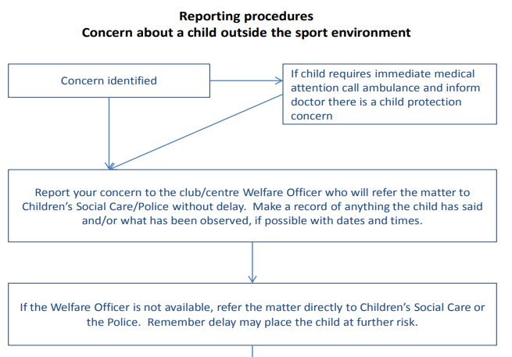

If the concern is about someone at the club, the following flowchart should be followed:
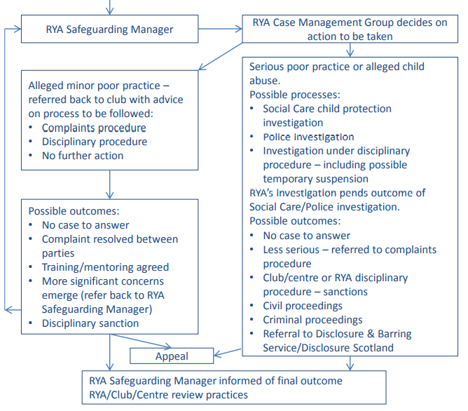
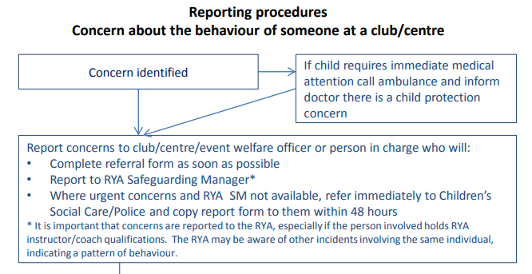

Useful Contacts
If it is an emergency, please ring the Police on 999

Priory Sailing Club Welfare Officer
Jeanette Pocock 01234 358811, 07786 154236 jlile@hotmail.co.uk

Bedford Borough Safeguarding Team
Contact the Multi Agency Support Hub (MASH) on 01234 718700 (office hours) or 0300 300 8123 (out of hours)

Royal Yachting Association Safeguarding and Equality Manager
RYA House, Ensign Way Hamble Southampton SO31 4YA
Tel: 023 8060 4104
E-mail: safeguarding@rya.org.uk
Website: www.rya.org.uk/go/safeguarding

NSPCC
24 hour free helpline 0808 800 5000
E-mail: help@nspcc.org.uk
Website: www.nspcc.org.uk

Childline
24 hour free helpline 0800 1111
Website: www.childline.org.uk

MIND – mental health charity
Tel: 0300 123 3393
Text: 86463
E-mail: info@mind.org.uk
Website: www.mind.org.uk

Child Protection in Sport Unit (CPSU)
Website: www.thecpsu.org.uk
Tel: 0116 366 5580
E-mail: cpsu@nspcc.org.uk
Details of Children’s Social Care departments and emergency duty teams are listed below. If you are unable to find the appropriate contact number, call the RYA’s Safeguarding and Equality Manager or, if a child is at immediate risk, the Police.
The RYA’s Safeguarding and Equality Manager on 023 8060 4104
NSPCC free 24-hour helpline 0808 800 5000.

Priory Sailing Club - PSC Safeguarding Appendix G
Private and Confidential
Self-declaration form for roles involving contact with children and vulnerable adults
Priory Sailing Club is committed to safeguarding children from physical, sexual and emotional harm. As part of our Safeguarding policy, we require anyone acting on behalf of the club whose duties will involve contact with children to complete this self-declaration form.
All information will be treated as confidential and managed in accordance with our Data Privacy Policy and current data protection legislation and guidance.

Name …………………………………………………………………………………………..

- Have you ever been known to any Children’s Services Department as being an actual or potential risk to children? YES / NO
If yes, please supply details.
- Have you ever been the subject of any disciplinary investigation and/or sanction by any organisation due to concerns about your behaviour towards children? YES / NO
If yes, please supply details.
Declaration
I declare that to the best of my knowledge the information given above is correct and understand that any misleading statements or deliberate omission may be sufficient grounds for disciplinary action and/or the withdrawal of my appointment.
If required I agree to provide a valid Criminal Records Disclosure.
I agree to inform Priory Sailing Club within 24 hours if I am subsequently investigated by any agency or organisation in relation to concerns about my behaviour towards children or young people.
I understand that the information contained in this form and in the Disclosure, or supplied by third parties, may be shared with other persons or organisations in circumstances where this is considered necessary to safeguard children.
Signed: ………………………………………………………….. Date: ……………………………
Note: if the applicant is aged under 18, this form should be counter-signed by a parent or guardian
Priory Sailing Club - PSC Safeguarding Appendix H
What is child abuse?
(Adapted from RYA Safeguarding and Child Protection Guidelines Jan 2020 )

Abuse and neglect are forms of maltreatment of a child. Somebody may abuse or neglect a child by inflicting harm, or by failing to act to prevent harm. Children may be abused in a family or in an institutional or community setting by those known to them or, more rarely, by others (including via the internet). They may be abused by an adult or adults, or another child or children.
Physical abuse may involve adults or other children inflicting physical harm:
• hitting, shaking, throwing, poisoning, burning or scalding, drowning or suffocating • giving children alcohol or inappropriate drugs
• a parent or carer fabricating the symptoms of, or deliberately inducing, illness in a child
• in sport situations, physical abuse might also occur when the nature and intensity of training exceeds the capacity of the child’s immature and growing body.

Emotional abuse is the persistent emotional maltreatment of a child such as to cause severe and persistent adverse effects on the child’s emotional development. It may involve:
• conveying to a child that they are worthless, unloved or inadequate
• not giving the child opportunities to express their views, deliberately silencing them or ‘making fun’ of what they say or how they communicate
• imposing expectations which are beyond the child’s age or developmental capability
• overprotection and limitation of exploration and learning, or preventing the child from participating in normal social interaction
• allowing a child to see or hear the ill-treatment of another person
• serious bullying (including cyber bullying), causing children frequently to feel frightened or in danger
• the exploitation or corruption of children
• emotional abuse in sport might also include situations where parents or coaches subject children to constant criticism, bullying or pressure to perform at a level that the child cannot realistically be expected to achieve. Some level of emotional abuse is involved in all types of maltreatment of a child.

Sexual abuse abuse involves an individual (male or female, or another child) forcing or enticing a child or young person to take part in sexual activities, whether or not the child is aware of what is happening, to gratify their own sexual needs.
The activities may involve:
• physical contact (eg. kissing, touching, masturbation, rape or oral sex)
• involving children in looking at, or in the production of, sexual images
• encouraging children to behave in sexually inappropriate ways or watch sexual activities
• grooming a child in preparation for abuse (including via the internet)
• sport situations which involve physical contact (eg. supporting or guiding children) could potentially create situations where sexual abuse may go unnoticed.

Abusive situations may also occur if adults misuse their power and position of trust over young people.

Neglect is the persistent failure to meet a child’s basic physical and/or psychological needs, likely to result in the serious impairment of the child’s health or development. Neglect may involve a parent or carer failing to:
• provide adequate food, clothing and shelter
• protect a child from physical and emotional harm or danger
• ensure adequate supervision
• ensure access to appropriate medical care or treatment
• respond to a child’s basic emotional needs
• neglect in a sport situation might occur if an instructor or coach fails to ensure that children are safe, or exposes them to undue cold or risk of injury.

Additional vulnerability
Instructors, coaches and volunteers should be aware that some children may be more vulnerable to abuse or find it more difficult to express their concerns. For example:
• a disabled child who relies on a carer to help them get changed may worry that they won’t be able to sail any more if they report the carer
• a deaf child may not be able to express themselves or speak confidentially if they need an interpreter
• a child who has experienced racism may find it difficult to trust an adult from a different ethnic background
• children with low self-esteem or mental health problems can be more vulnerable to bullying or abuse, as can gay, lesbian, bisexual or transgender young people, or any child who has a characteristic that marks them out in others’ eyes as ‘different’.

Child sexual exploitation is a form of child sexual abuse. It occurs where an individual or group takes advantage of an imbalance of power to coerce, manipulate or deceive a child or young person under the age of 18 into sexual activity in exchange for something the victim needs and wants (eg. attention, money or material possessions, alcohol or drugs), and/or for the financial advantage or increased status of the perpetrator or facilitator. The victim may have been sexually exploited even if the sexual activity appears consensual. Child sexual exploitation can also occur online without involving physical contact.

Extremism goes beyond terrorism and includes people who target the vulnerable - including the young - by seeking to: sow division between communities on the basis of race, faith or denomination; justify discrimination eg. towards women and girls; persuade others that minorities are inferior; or argue against the primacy of democracy and the rule of law in our society.

Bullying (including online bullying, for example via text or social media) may be seen as deliberately hurtful behaviour, usually repeated or sustained over a period of time, where it is difficult for those being bullied to defend themselves. The bully is often another young person. Although anyone can be the target of bullying, victims are typically shy, sensitive and perhaps anxious or insecure. Sometimes they are singled out for physical reasons – being overweight or physically small, being gay or lesbian, having a disability or belonging to a different race, faith or culture. Bullying can include:
• physical pushing, kicking, hitting, pinching etc
• name calling, sarcasm, spreading rumours, persistent teasing and emotional torment through ridicule, humiliation or the continual ignoring of individuals
• posting of derogatory or abusive comments, videos or images on social network sites
• racial taunts, graffiti, gestures, sectarianism
• sexual comments, suggestions or behaviour
• unwanted physical contact.

The acronym STOP – Several Times On Purpose - can help you to identify bullying behaviour.

Grooming
Instructors, coaches and volunteers should be aware that children and young people can be groomed online or face-to-face, by a stranger or by someone they know - for example a family member, friend or professional. Grooming is when someone develops a relationship with a child over a period of time to gain their trust for the purposes of sexual abuse or exploitation.
Sometimes the perpetrator grooms the entire family, building a relationship with the child’s parents/carers so that they are allowed more access to the child than would normally be the case. Similar behaviour could be used to radicalise young people and recruit them to a religious or political cause.

Recognising Abuse
It is not always easy, even for the most experienced carers, to spot when a child has been abused.
However, some of the more typical symptoms which should trigger your suspicions would include:
• unexplained or suspicious injuries such as bruising, cuts or burns, particularly if situated on a part of the body not normally prone to such injuries
• sexually explicit language or actions
• a sudden change in behaviour (eg. becoming very quiet, withdrawn or displaying sudden outbursts of temper)
• the child describes what appears to be an abusive act involving him/her
• a change observed over a long period of time (eg. the child losing weight or becoming increasingly dirty or unkempt)
• a general distrust and avoidance of adults, especially those with whom a close relationship would be expected
• an unexpected reaction to normal physical contact
• difficulty in making friends or abnormal restrictions on socialising with others.

It is important to note that a child could be displaying some or all of these signs, or behaving in a way which is worrying, without this necessarily meaning that the child is being abused. Similarly, there may not be any signs, but you may just feel that something is wrong. If you have noticed a change in the child’s behaviour, first talk to the parents or carers. It may be that something has happened, such as a bereavement, which has caused the child to be unhappy.

If you are concerned
If there are concerns about sexual abuse or violence in the home, talking to the parents or carers might put the child at greater risk. Please refer to ‘Priory Sailing Club’s document ‘What to do if you are concerned about a child’. Our designated Welfare Officer is Jeanette Pocock and it is this person’s responsibility to make the decision to contact Children’s Social Care Services or the Police. It is NOT their responsibility to decide if abuse is taking place, BUT it is their responsibility to act on your concerns.

Priory Sailing Club - PSC Safeguarding Appendix J
Safeguarding and Child Protection Referral Form
Date and time of incident
Name and position of person about whom report, complaint or allegation is made
Name and age of child involved
Nature of incident, complaint or allegation (continue on separate page if necessary.
Action taken by organisation (continue on separate page if necessary)
If Police or Children’s Social Care Services contacted, name, position and telephone number of person handling case
Name, organisation and position of person completing form
Contact telephone number and e-mail address
Signature of person completing form
Date and time form completed
Name and position of Priory Sailing Club’s child protection/welfare officer or person in charge (if different )
Contact telephone number and e-mail address
This form should be copied, marked ‘Private and Confidential’, to the RYA Safeguarding and Equality Manager, Jackie Reid, RYA House, Ensign Way, Hamble, Southampton, SO31 4YA e-mail safeguarding@rya.org.uk and to the statutory authorities (if they have been informed of the incident) within 48 hours of the incident.

